Experiment 1: Measurement of Self-Inductance By Maxwell's Bridge

Name: MANSI UNIYAL

Roll no.: 19EE10039

**Derivation:**

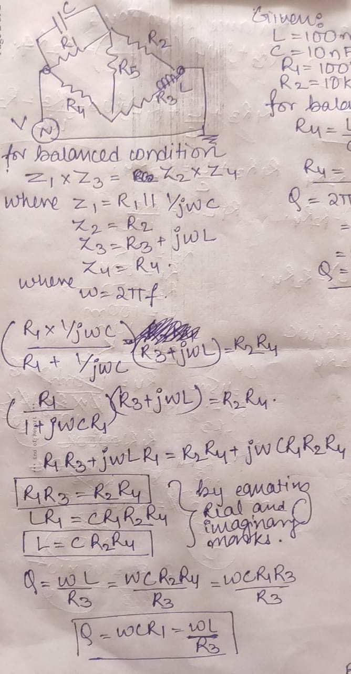

1. Use L1=100 mH, R1= 100 kΩ, C1=10 nF and R2=10 kΩ. What is the value of R4 to achieve balance condition? Now, plot current through the detector (i.e., the resistor of 50 Ω) by varying the resistance R2 from 500 Ω to 50 kΩ. Show 10 readings and attach the screenshots of the plot. Comment on your results. What is the Q factor of the coil? Use a sinusoidal supply voltage (V1) having a peak value of 10 V and a frequency of 1 kHz? (10)

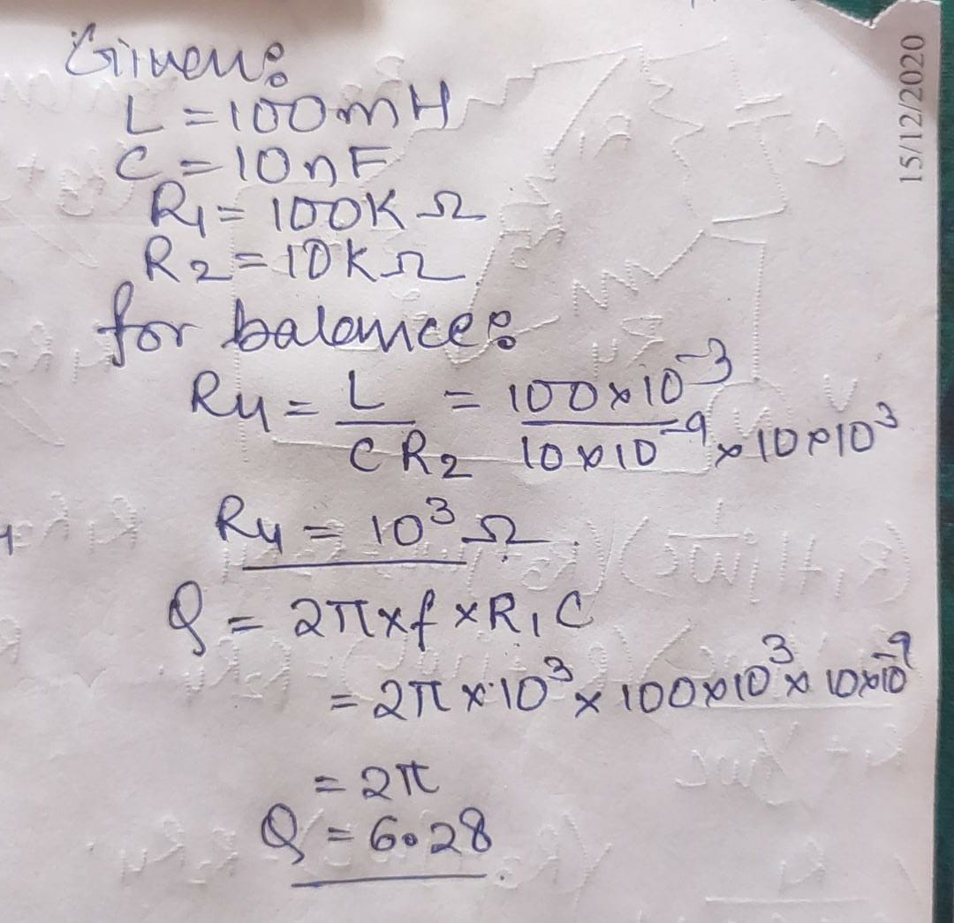

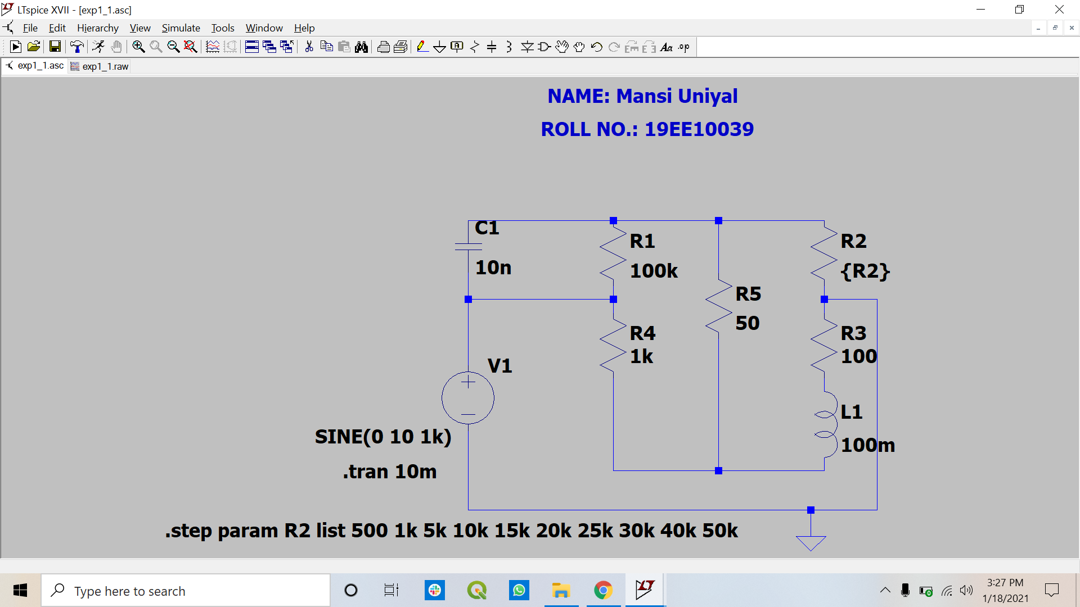

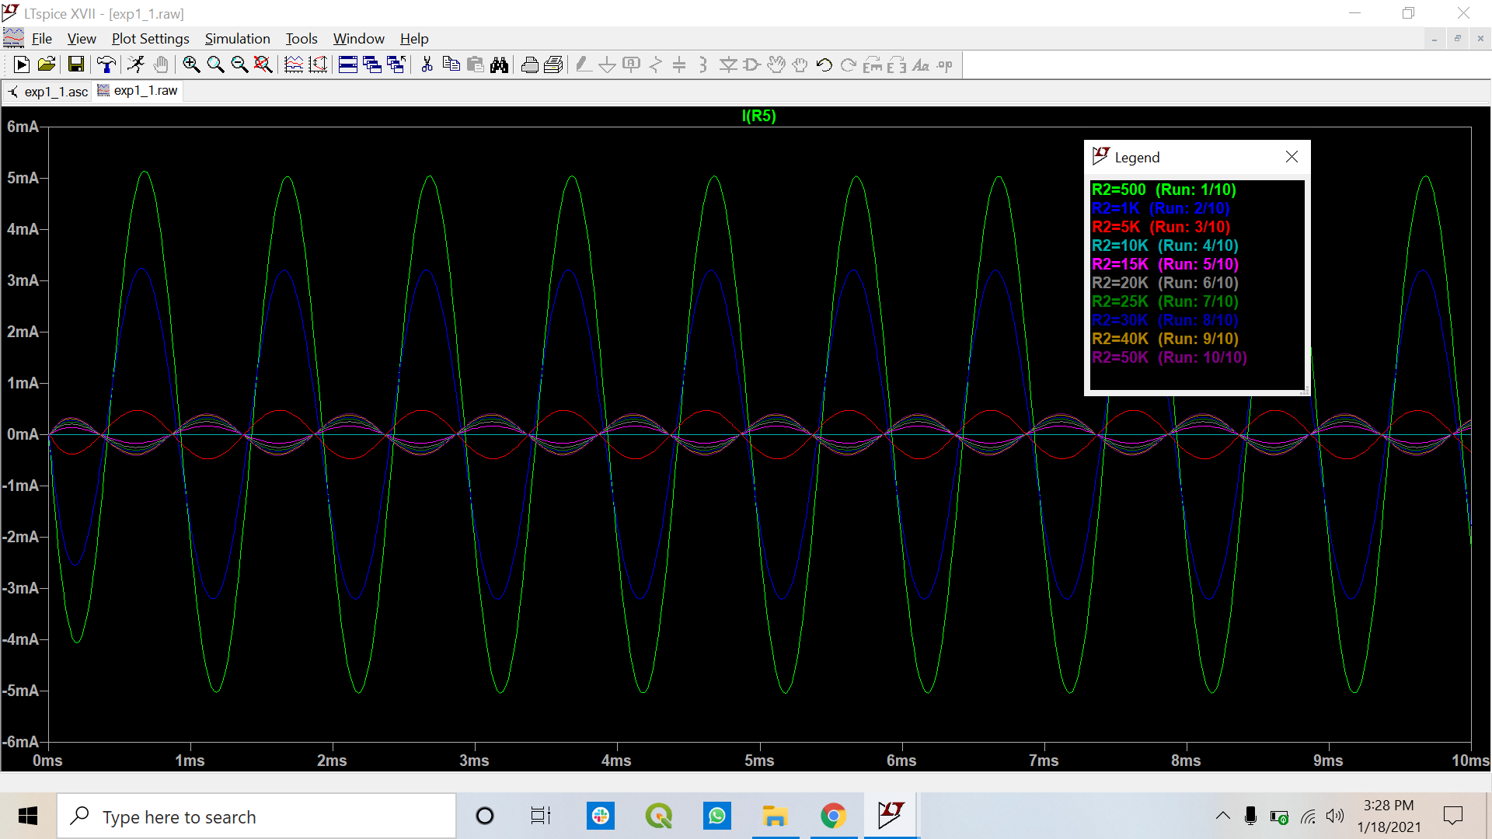

1. After achieving the balanced condition in step 2, replace the coil with an inductance of LX=45 mH, and Q=2. Show the plot of the detector current in this condition? Then, vary the values of the resistors R1, R2, and R4 (assuming C1 is fixed as before) in order to achieve the new balanced condition. Show the plot of the detector current underbalanced condition. Report the component values and comment on these result. (10)

